**The percent share of finger millet cultivation area, Parthenium occurrences area and Ageratina adenophora occurrences area in different localities of CHAL using digital globe imaginaries (2.5m resolution)**

**Methodology**

**Data and Data source**

1. A total of six pieces of Digital globe imageries (different months of 2018) of 2X2m resolution that covered parts of Chitwan, Nawalparasi, Tanahu, Kaski, Ramdi (Syangja and Palpa) and Myagd I (Myagdi and Parbat) districts within CHAL region were purchased from Geospatial Private Limited.
2. A total of 314.64 Sq km area within CHAL was used for processing.
3. Each image was projected to WGS 1984 UTM Zone 44 and 45

**Data processing**

1. Supervised classification algorithm was used for processing to prepare land use map
2. Each individual image was subjected to supervised classification in Erdas imagine software with minutely quoting the physical characteristics of an area within image for the formation of land use image.
3. Sufficient training samples in signature of each physical characteristics of image (like river, residential area, forests etc) were taken from image.
4. Representative areas for each desired class were located in the image with sufficient number of pixels covering the known physical characterstics. A statistical file known as signature was then generated, by the image processing software (Erdas imagine software), for each class. Each pixel was then assigned to the most likely class based on the maximum likelihood algorithm, the most commonly used classification algorithm (Jensen, 1996; Schowengerdt, 1997)
5. The training samples for signature file were selected based on visual estimation, locating from the GPS points collected from field survey, estimating association of the possible area/ characters , following the reflectance value of particular pixel within the physical characteristics in image.
6. The final land use map was prepared through supervised classification.
7. The finger millet specieswas speculated within the bariland of each individual image. Signature for Parthenium occurrence were generated using gps location and expert observation in four imageries (Chitwan, Nawalparasi, Tanahu, and Myagdi). Classification for two imageries (Kaski and Ramdi) could not be performed due to absence of occurrence locations for the species parthenium. Similarly, the occurrences for *Ageratina adenophora* were identified from the places nearby rivers, gullies, roadsides, degraded forests and also from the GPS locations taken during the field survey. Species occurrences were quoted with dark red colour in the map.
8. The final image was prepared from Arc GIS following general steps of map processing.

References

Jensen, J. R. 1996. Introductory Digital Image Processing: A Remote Sensing Perspective, 2nd edition, Prentice Hall, New Jersey.

Schowengerdt, R. 1997. Remote Sensing: Models and Methods for Image Processing, 2nd edition, Academic Press, London.

Table 1: Total area of an individual image and finger millet cultivation area estimated through supervised classification

|  |  |  |  |  |  |
| --- | --- | --- | --- | --- | --- |
| **SN** | **Location** | **Total area Km2** | **Fm % share** | ***Parthenium* % share** | ***Ageratina* % share** |
| 1 | Myagdi | 33.038 | 11.97 | 1.84788 | 13.3053 |
| 2 | Kaski | 74.79 | 3.31 | - | 5.02335 |
| 3 | Ramdi | 48.17 | 5.17 | - | 13.3911 |
| **4** | Nawalparasi | 45.58 | 4.61 | 4.25 | 13.7329 |
| **5** | Tanahu | 47.67 | 2.73 | 5.34724 | 5.37344 |
| **6** | Chitwan | 68.35 | - | 1.67254 |  |
|  | Total | 314.64 |  |  |  |

Table 2: Bari land indicate the percent of finger millet cultivation in each map

|  |  |
| --- | --- |
| Myagdi | E:\DRL1\digital_globe_high resolution image\myagdi.jpg |
| Ramdi | E:\DRL1\digital_globe_high resolution image\Ramdi.jpg |
| Tanahu | E:\DRL1\digital_globe_high resolution image\Tanahu.jpg |
| Nawalparasi | E:\DRL1\digital_globe_high resolution image\nawalparasi.jpg |
| Kaski | E:\DRL1\digital_globe_high resolution image\Kaski.jpg |

Table 3: Landuse classification map for individual image showing Parthenium occurrence

|  |  |
| --- | --- |
| Myagdi |  |
| Tanahu |  |
| Nawalparasi |  |
| Chitwan |  |

**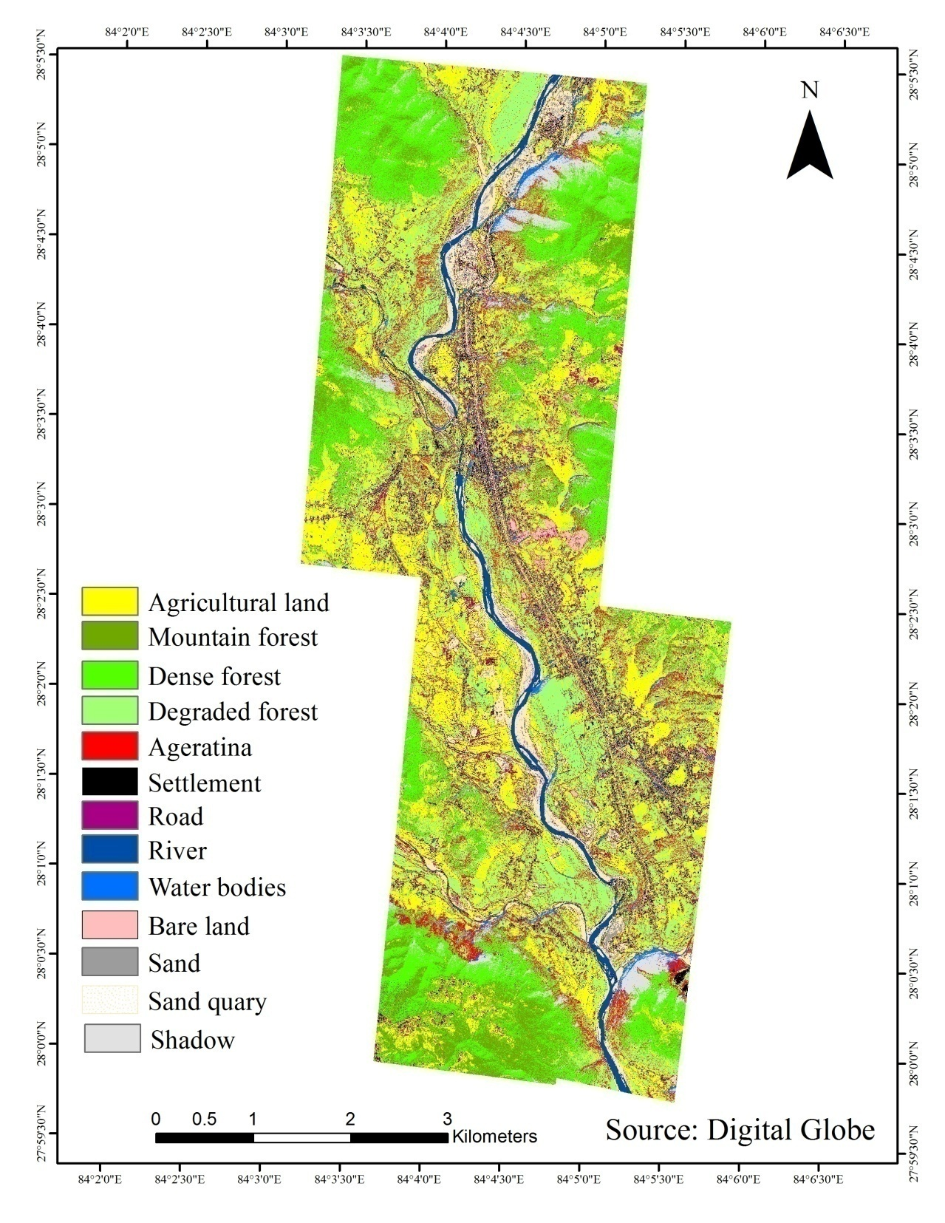**

**Fig: Land use classification map showing occurrences of *Ageratina adenophora* in Tanahun.**

**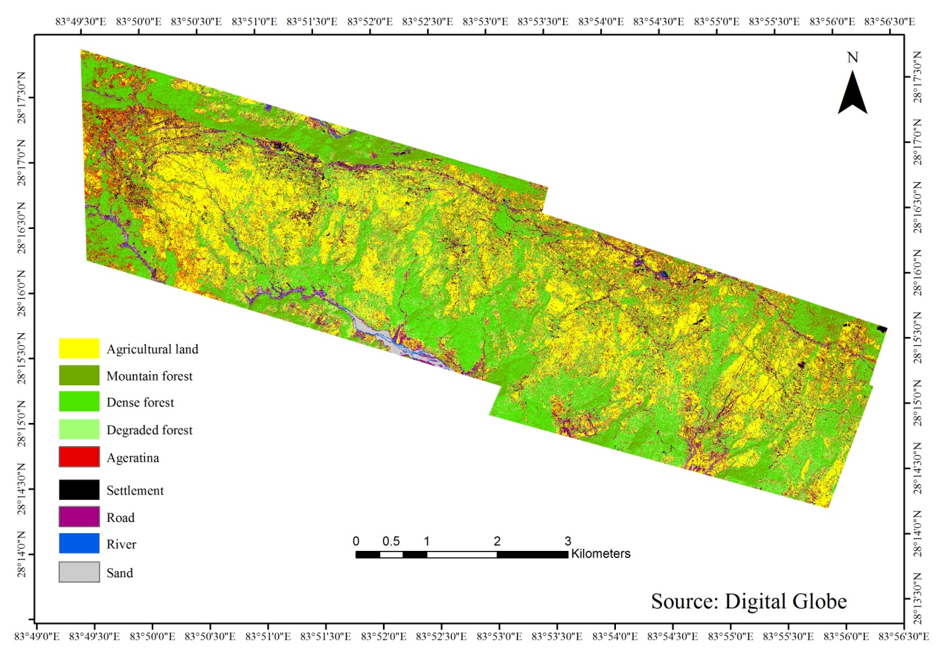**

**Fig: Land use classification map showing occurrences of *Ageratina adenophora* in Kaski.**

**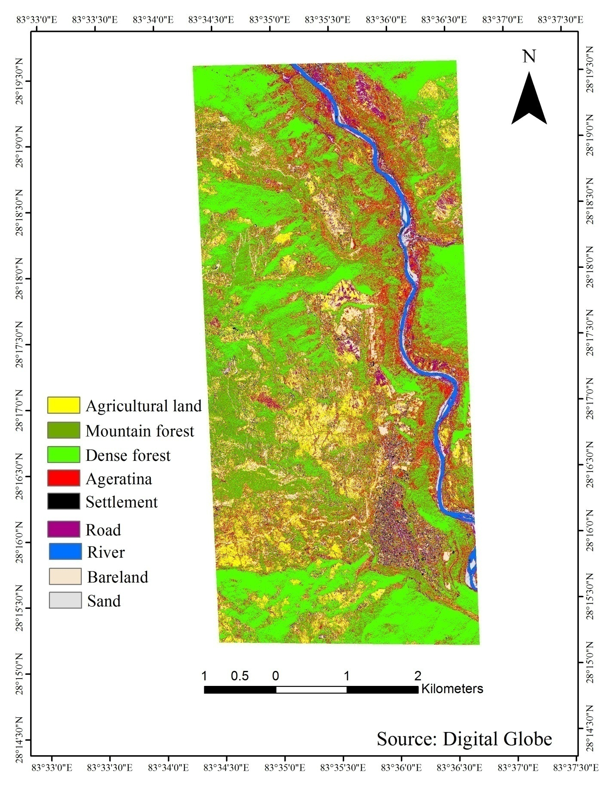**

**Fig: Land use classification map showing occurrences of *Ageratina adenophora* in Myagdi**

**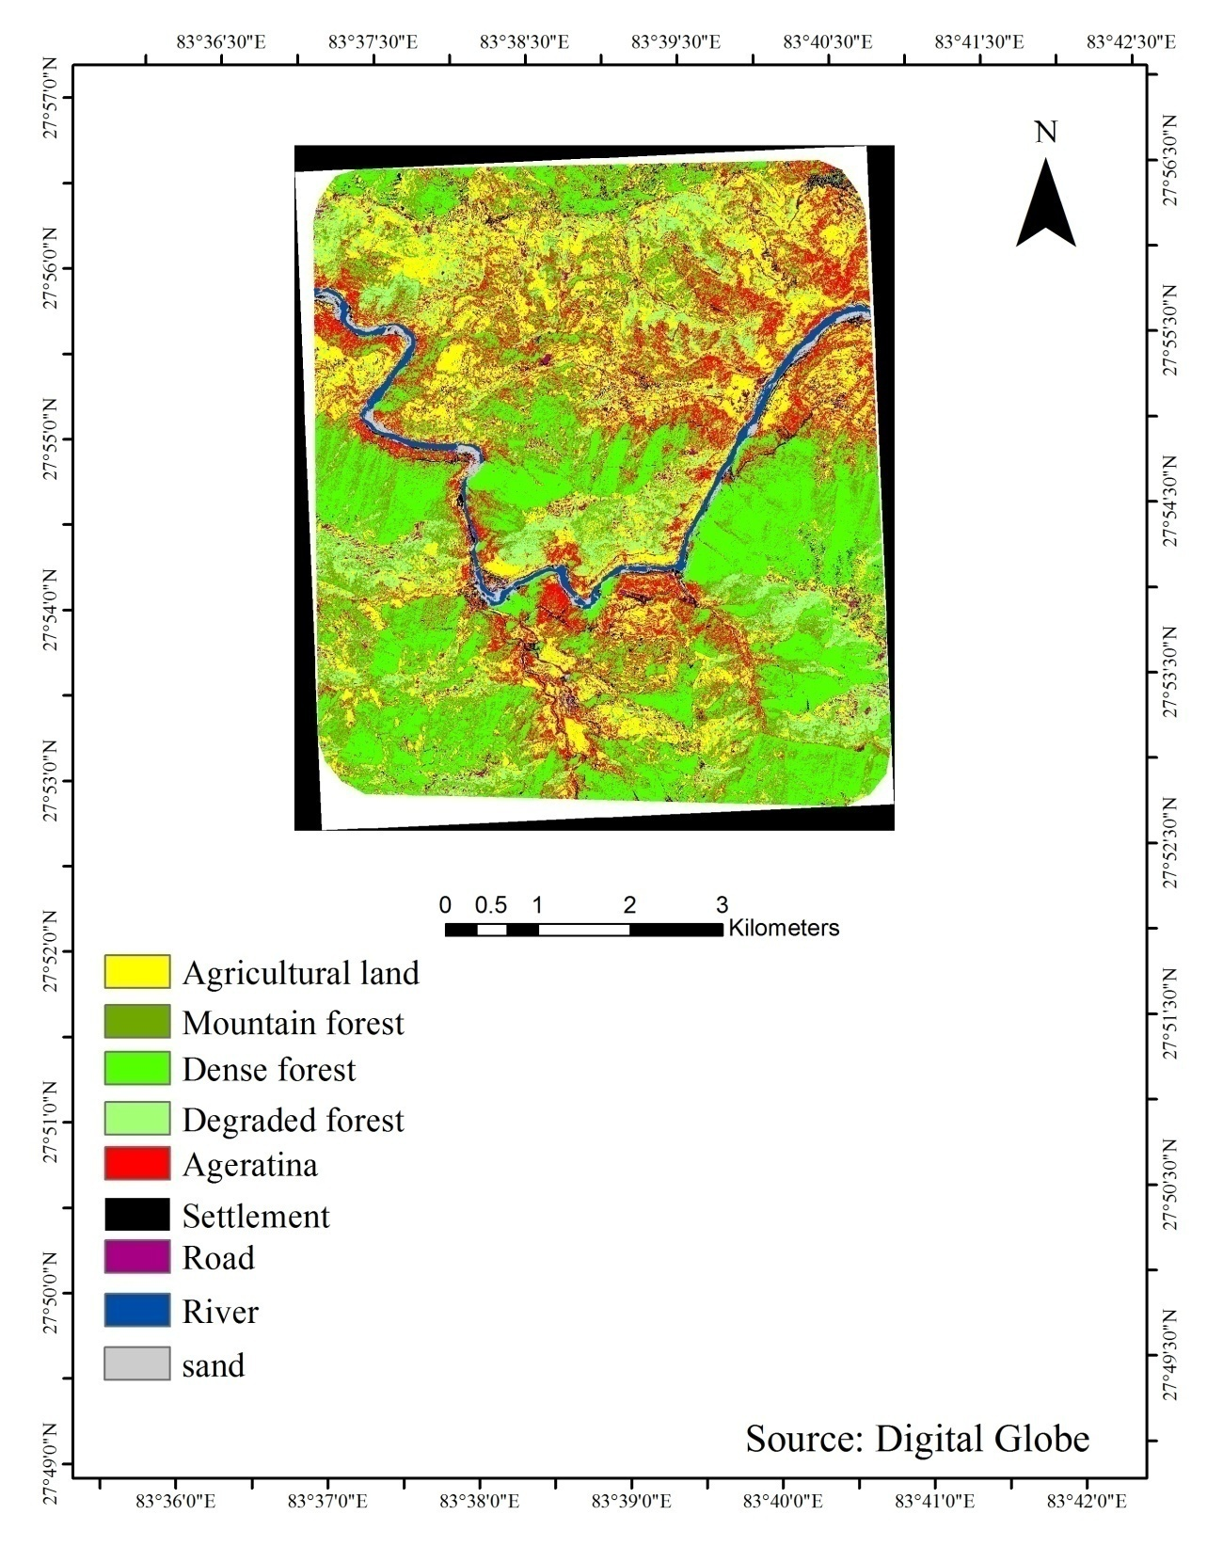**

**Fig: Land use classification map showing occurrences of *Ageratina adenophora* in Ramdi**

**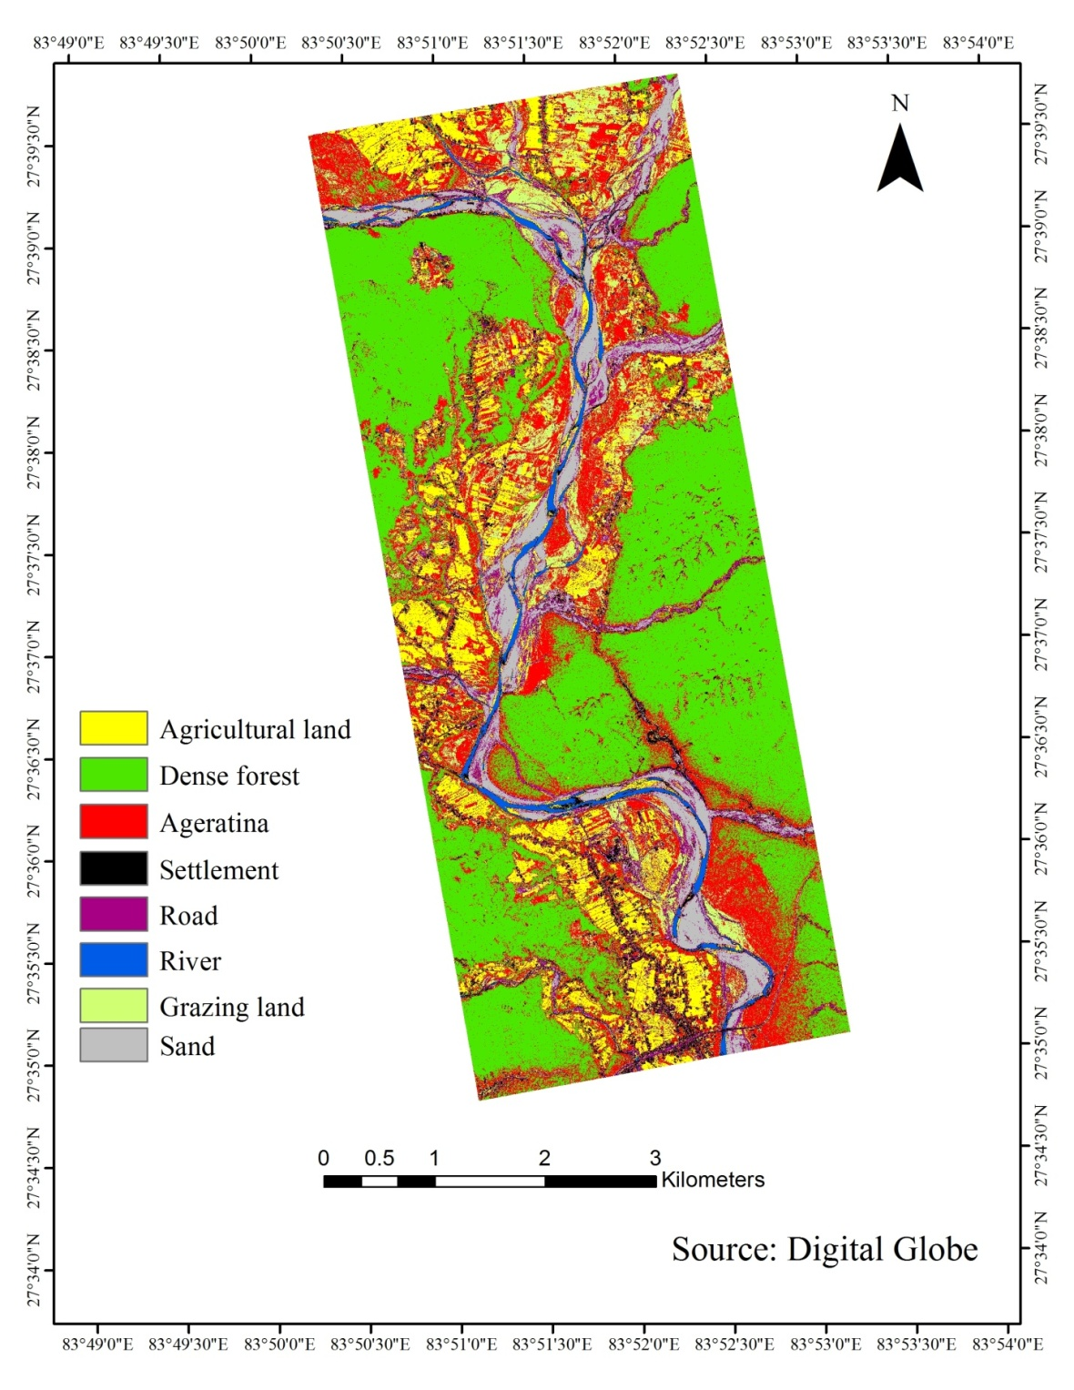**

**Fig: Land use classification map showing occurrences of *Ageratina adenophora* in Nawalparasi**

**Methods for landsat-8 for knowledge base classification**

Landsat-8 image (image acquisition)

Radiometric correction

Clustering------ unsupervised classification

Supervised classification (based on digital global, GPS points from field survey)

1 Class Map----supervised+ unsupervised

2 DEM – Slope, aspect, altitude

3 Meteorological- Tmax, Tmin, Precipitation

4 NDVI

Knowledge base classification and class (input from points 1-4)

Classification-filtering- species